2025 ANNUAL BALLOT

Instructions: Please print a copy of this ballot, enter your contact information below, list the sanctioned battles you participated in, circle your choices, and sign it at the end. Per the Bylaws of the Club only those who have battled in a sanctioned event in the past 24 months may vote. Those who have battled in either the 2024 or 2025 Championship (Nats) will have their votes counted twice. Bylaws revisions and Rules revisions which receive 2/3 or more favorable votes shall be adopted and shall become effective on January 1, 2026. The Bylaws of the Club and the laws under which the Club is incorporated require that this ballot be returned BY MAIL. IT MAY NOT BE E-MAILED. Please mail this ballot before 15-Sept-2025.

Mail the completed ballot to:

Matthew Andrews
28 Holly Cove Lane
Dover, DE 19901

Name (Print): _____________________________________

E-mail:________________________ Your phone: (_____)________________

Street address: ___________________________

City/town , State/Prov. ZIP/Postal Code ________________________

I have battled in the following IRCWCC sanctioned events in the past 24 months (no need to list all battles) (List Nats 2024, 2025 first if applicable):

______________________________________________________________________________

______________________________________________________________________________

Election of Member-at-Large
Comment: The Member at Large represents all the members of the IRCWCC on the E-board. The following individual(s) were nominated for Member-at- Large of the Executive Board. Vote for one by circling that person’s name.

Andy Terpstra

Site for 2025 Annual Championship (Nats) (Circle One)

Site Site Host
Statesboro, GA Biran Koehler

Dates for 2025 Annual Championship (Nats) (Circle One)

June 14th-19th June 21st -26th

Contest Director 2025 Annual Championship (NATS) (Circle One)

Matt Larson

Please vote on the following rules proposals which passed the 2025 Rules Committee Meeting vote. See page 5 for rule proposal text.

Rule Proposal 2025.1 - Stop 5 minute timer when checking moss, accessing ram damage

Yay – Add rule to stop timer

Nay – Leave rule as is

Rule Proposal 2025.2 – WW2 South Dakota increase speed to 24 seconds

Yay – Add exception to rules to allow WW2 South Dakota be 24 Seconds

Nay – Leave WW2 South Dakota at 26 Seconds

Rule Proposal 2025.3 - Better define “turning motors”

Yay – Amend Rule for “turning motors”

Nay – leave rule as is

Rule Proposal 2025.4 - Update rule for going hot/cold

Yay – Update going cold rule

Nay – Leave rule as is

Rule Proposals 2025.5 - Eliminate 1⁄4 unit cannon rule

Yay – Eliminate ¼ cannon from rules

Nay – leave ¼ cannon in rules

Rule Proposal 2025.6 - Shore Bombardment/Defensive Battery Revamp

Yay – Change campaign rules to change base setup/ Defensive Batteries

Nay – Leave campaign rule as is

Rule Proposal 2025.7 - Allow Convoy Ships to use Bailing Out/Dewatering Pumps

Yay – Change convoy ships to have pumps to bail

Nay – Leave rule as is

Rule Proposal 2025.8 - Clarify Pump Discharge/Restrictor with current accepted practice

Yay – Change wording to allow easier testing of pumps

Nay – Leave rule as is

Rule Proposal 2025.9 - Convoy Raider Rule

Yay – Add convoy Raiders to Campaign Rules

Nay – Don’t amend campaign Rules

Rule Proposal 2025.10 - Hull depth and waterline

Yay – Amend rules to clarify Waterline Rule

Nay – Leave rule as is

RULE 2025.1

Title: Stop 5 minute timer when checking moss, accessing ram damage

Purpose: To have the 5 minute timer stop while checking moss, accessing ram damage.

Author: Tyler Helland
Cosigners: McCoy Helland, Bob Hoernemann, Zach Hoernemann, Matthew Larson

Existing:

PART III - BATTLE
C. BATTLE
1. The 5 Minute Rule
a. A Captain may withdraw a ship from a sortie by announcing to all participants that "The [name of ship] is on five!" For ships in Class 1, the announcement shall be "The [name of ship] is on two!"
b. After invoking the Five Minute Rule (or Two Minute Rule) the captain shall start a timer, and the ship must remain in the battle for five minutes (two minutes for Class 1) before being touched by its captain or removed from the water. During that five minute (or two minute) period, the ship trying to withdraw shall not fire on opposing ships, but it may be fired upon by any other ship which is not also "on five" or "on two."
c. A captain may not announce that a ship is "on five" or "on two" while anyone is in the water.
d. At the expiration of the required five minute or two minute period the withdrawing ship must be brought to shore immediately and may not be fired upon. After the ship has been touched by its captain or removed from the water it may not reenter the ongoing sortie. The ship may enter subsequent new sorties if any are scheduled in the same battle.

Proposed:

PART III - BATTLE
C. BATTLE
1. The 5 Minute Rule
a. A Captain may withdraw a ship from a sortie by announcing to all participants that "The [name of ship] is on five!" For ships in Class 1, the announcement shall be "The [name of ship] is on two!"
b. After invoking the Five Minute Rule (or Two Minute Rule) the captain shall start a timer, and the ship must remain in the battle for five minutes (two minutes for Class 1) before being touched by its captain or removed from the water. During that five minute (or two minute) period, the ship trying to withdraw shall not fire on opposing ships, but it may be fired upon by any other ship which is not also "on five" or "on two."
c. The five minute timer is paused while a ship “on five” is in the act of clearing moss (after the 30 second waiting period during which it is still in combat) and also while accessing for suspected ram damage
d. A captain may not announce that a ship is "on five" or "on two" while anyone is in the water.
e. At the expiration of the required five minute or two minute period the withdrawing ship must be brought to shore immediately and may not be fired upon. After the ship has been touched by its captain or removed from the water it may not reenter the ongoing sortie. The ship may enter subsequent new sorties if any are scheduled in the same battle.

Ships affected – all
Reasoning:
Though I do not believe this loophole has been frequently exploited, the rule does already state that a ship “on five” is to “remain in the battle.” In my opinion the intention is to have a full 5 minutes of uninterrupted battle where the ship is a viable target. I worry that in the future this loophole could become problematic and abused.

RULE 2025.2

Rule proposal: Make WW2 South Dakota 24 second speed
Author: Caleb Smith
Cosigners: Steve Andrews, Bryan Box

Add to PART II - APPENDIX B

4.) WW2 USS South Dakota class shall be 24 seconds speed.

Reasoning:
Trying again, USS South Dakota is a modern battleship that is in the same speed bracket as
North Carolina and Nagato but gets penalized in speed because of her shorter length. Speed by
length works surprisingly well for the rest of the ships in the hobby but Sodak deserves 24
seconds to put her in the bracket of ships she belongs in. This will not take anything from the
North Carolina. They're proven solid ships that turn really really well. Sodak is similar but not
worth building being slower than comparable ships. Let's get her the speed she deserves!

RULE 2025.3

Proposal: Better define “turning motors”
Author: Caleb Smith
Cosigners: Kevin Plumer, Steve Andrews, Will Tustin, Bryan Box, Justin Ragucci
Current rule:
PART II
D. RUDDERS
1. Only rudders shall be used to steer ships. No "turning motors" or other systems may
be used to assist in turning.

Proposed rule:
PART II
D. RUDDERS
1. Only rudders shall be used to steer ships. Any non-rudder turn assisting system, differential
steering, or the active varying of shaft speeds relative to each other to assist in turning is
prohibited.

Reasoning:
We have the potential for a lot of growth this year and going forward. The club is getting
increased exposure and a lot more people will be looking at our website, rules, and
hopefully building ships. There are some rules that aren't exactly spelled out well but
every captain can tell you what it means. I.E. turning motors. We all know the spirit of
the rule and what it's saying can't be done but this should be spelled out so anyone
looking at the rules can understand it, regardless of background/experience in the
hobby. I believe this spells out our intent without preventing established practices of
using outboard shafts for straight reverse and other things.

RULE 2025.4

Proposal: Update rule for going hot/cold
Author: Caleb Smith
Cosigners: Tyler Helland, Kevin Plumer, Will Tustin, Bryan Box

Current rule:

Part I. C.
3. If all ships competing at an event are off the water and in the pit area, a Contest Director may
give the command "Make the area safe!" All Captains shall immediately disconnect or turn off
the supply of gas, verify that each cannon is pinned, and verify that the ship's radio receiver and
the appropriate transmitter are turned off. When the C. D. is satisfied that these actions have been
taken by all Captains, the announcement "The area is safe!"may be made, and safety glasses may
be temporarily removed. No Captain shall reconnect or turn on a gas supply, or turn on a receiver
or transmitter, until the C. D. announces "The area is no longer safe!" and all persons have again
put on safety glasses.

Proposed Rule:

Part I. C.
3. If all ships competing at an event are off the water and in the pit area, a Contest Director may
give the command "Make the area safe!” or “Going Cold!" All Captains shall immediately
remove any supply of gas, vent any residual pressure including expansion tanks with check
valves, and verify that each cannon is pinned. When the C. D. is satisfied that these actions have
been taken by all Captains, the announcement "The area is safe!" or “Range Cold!” may be
made, and safety glasses may be temporarily removed. No Captain shall reconnect or turn on a
gas supply until the C. D. announces "The area is no longer safe!" or “Range Hot!” and all
persons have again put on safety glasses.
This proposal aims to update the practice of going Hot/cold to a modern standard. I've worked
with Tyler, the president, and Will, our current CD, on the wording to establish a current safety
standard. This doesn't change the way battles are conducted, more like update the rules to what
we're currently doing and remove practices pertinent to older technology.

RULE 2025.5

Proposal: Eliminate 1⁄4 unit cannon rule
Author: Caleb Smith
Cosigners: Will Tustin, Lou Meszaros, Bryan Box
Current rule:

E. CANNONS
c. A 1⁄4 unit cannon carries 12 BB's if fired single shot, or 5 BB's if spurted.

Proposed rule:

E. CANNONS
c. Removed in 2025 version.

This is just a housekeeping proposal. The rules no longer have a provision for a 1⁄4 unit anything
so there’s no point in this being in there any longer.

RULE 2025.6

Title: Shore Bombardment/Defensive Battery Revamp

Author: William Tustin

Co-Signers: Caleb S, Lou M, Bryan B

Purpose:

The purpose of this proposal is to adopt as written rule some current common practices during the setup and running of the annual campaign battles at the national competition, in addition to some changes that would make the shore targets more impactful and also provide a reason to build a shore battery. In my 7 years of Nationals, I have never seen a shore battery even proposed to be used.

SEE ATTACHED GRAPHIC FOR EXAMPLE LAYOUT/INFO

Current Rule Text:

V. CAMPAIGN

B. PREPARATION

3. BASE CONSTRUCTION

a. Home bases and forward bases shall have 10 to 12 feet of shore line 6 feet into the water marked off by stakes. The sides of the bases shall be enclosed to prevent entry from the side.

b. A bombardment target frame upon which simulated supply and troop targets can be positioned shall be located at each forward base. This shall be constructed via option 1 or 2 below:

1) The bombardment target frames shall be 15' x 1' x 1" boards floating in the water adjacent to but not in front of each forward base.

i) A physical boundary shall be set up in the water to keep combat ships at least two (2) feet away from the bombardment target frame. This boundary shall be constructed low enough so that it does not prevent the shooting of simulated supply and troop targets by attacking combat ships.

ii) Ten "supply depot" targets and 10 "troop battalion" targets shall be placed on each target frame at the beginning of Campaign. These targets shall be equipped with small magnets to hold them in place but which permit them to be knocked over by ships' BB cannons. The depot targets shall be made of 1" round dowel or 1" square stock. Depot targets shall be 3" tall and troop battalions shall be 2" tall.

2) The bombardment target frame is constructed of a large section of foam board and anchored to the bottom of the pond at a distance agreed to by the CD and admirals. The 20 targets simulating depots and troops will be manufactured breakable BB gun targets.

I. SHORE BOMBARDMENT

1. Supply depot targets and troop battalion targets on the forward base target frame shall be engaged by enemy fleet BB cannon fire. The supply depot and troop battalion targets shall be deemed destroyed if they are knocked over as a result of the BB fire.

2. Supply depot targets knocked over as a result of a ship's wake or ram may be reset by and at the discretion of the Contest Director.

J. SHORE BATTERIES

1. Each forward base may have one shore battery.

2. Shore batteries shall be located on the forward base in the center of the target.

3. Each shore battery is allowed one cannon with a 75 round BB magazine.

4. Each battery must have a knock down target which shall disable the cannon if it is hit by cannon fire.

PROPOSED CHANGES:

V. CAMPAIGN

B. PREPARATION

3. Base Construction

a. NO CHANGES

b. A bombardment target frame upon which simulated supply and troop targets can be positioned shall be located at each forward base. This shall be constructed out of a large section of foam board and anchored to the pond bottom, adjacent to the shoreline, with another foam board vertically behind the targets to protect captains on shore. The distance away from the forward base will be agreed upon by the CD and admirals. The 20 targets simulating depots and troops will be manufactured, breakable, BB gun targets.

- SHORE BOMBARDMENT

1. Supply depot targets and troop battalion targets on the forward base target frame shall be engaged by enemy fleet BB cannon fire. The supply depot and troop battalion targets shall be deemed destroyed if any part of the manufactured, breakable, BB gun target has been damaged or destroyed by BB gun fire.

2. Supply depot targets knocked over as the result of ship’s wake or ram may be reset by and at the discretion of the Contest Director.

J. SHORE BATTERIES

1. Each forward base may have one shore battery. Shore batteries will be constructed and operated to all existing IRCWCC cannon safety and CO2 gas system safety rules. Shore batteries will be immobile objects that are physically anchored in position/orientation.

2. Shore batteries may be positioned at the discretion of the owning team’s admiral, with approval of the Contest Director for safety considerations. Batteries must be placed within reach of the “One Foot Wet” rule near the shoreline of the pond, and can not be placed in such a way as to fire directly into any of the Home/Forward bases, or up onto the shore, where people may be present. Shore batteries that float shall be anchored so as to not drift beyond the reach of the “One Foot Wet” rule near the shoreline of the pond.

3. Each shore battery is allowed one turret mechanism with two cannons, each with a 75 round BB magazine. Shore battery turrets are allowed to rotate a maximum of 180 degrees and are permitted to depress/elevate provided that they are mechanically limited to a maximum elevation of 0 degrees.

4. Shore Batteries may be retrieved, reloaded, recharged, and re-gassed so long as at least 1 friendly target on the forward base target frame remains undamaged. When retrieving the shore battery, the battery commander will announce "RECOVERING SHORE BATTERY" and is permitted to put ONE FOOT in the water, per the one foot wet rule, to retrieve the battery for re-arming. When replacing the battery after reloading, its overall position and orientation should remain the same, within a reasonable deviation.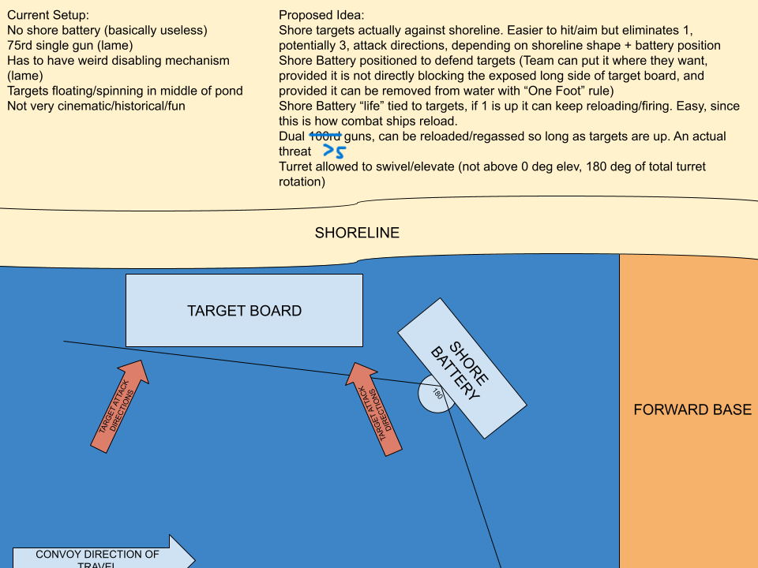

RULE 2025.7

Title: Allow Convoy Ships to use Bailing Out/Dewatering Pumps
Author: William Tustin
Co-Signers: Nate Armstrong, Kevin Plumer, Lou M
Purpose:
To legally permit convoy ships to use “dewatering” or “bailing out” pumps between legal campaign runs.
This is a practice that is already prevalent in the IRCWCC but is not strictly legal. This proposal aims to
properly adopt this common habit and properly regulate it.
Current Rule Text:
C. CONVOY SHIP CONSTRUCTION
1. A convoy ship may be any ship built or specifically refitted to transport supplies or troops.
These may include warships not normally used in fleet battles: aircraft carriers, submarines, small
destroyers and patrol craft.
2. Only convoy ships which were launched starting in 1905 through 1946, inclusive, and were
completed, are approved for IRCWCC Campaign.
3. Convoy ships shall be built in compliance with IRCWCC Construction Rules (see Part II).
4. The maximum speed of convoy ships shall be 34 seconds per 100 feet at full speed.
5. Convoy ships shall not carry any offensive units (cannons) or defensive units (pumps).

Proposed Rule:
Add Part V.C.5.a and .b
5. Convoy ships shall not carry any offensive units (cannons) or defensive units (pumps).
a. Convoy ships may have a pump installed to remove water between runs but shall not
activate the pump during a run. These pumps are not "defensive units" and are not
subject to the limitations on defensive units in C.5
b. The pump discharge must be visible when viewing the ship from all aspects. If a convoy
ship activates these pump(s) at any time during a run, that convoy ship will be declared
scuttled and must be immediately brought to shore and removed from the water.

RULE 2025.8

Title: Clarify Pump Discharge/Restrictor with current accepted practice
Author: William Tustin & Greg McFadden
Co-Signers: Nate Armstrong,Bryan Box
Purpose:
At the last 7 NATS there have been ships checked in with pumps whose restrictors were not immediately
checkable from outside the boat, and these ships have been passed because the pumps could be
otherwise easily checked by removing a hose clamp or sliding the pump out of its mount partially. A
current hobby vendor (SJS) also incorporates the restrictor into the pump housing, making it difficult to
check from outside the ship in many cases. We should officially change wording to adopt this widespread
behavior without compromising the ability of the CD to check pump restrictor diameter when necessary.
Rule Text:
G. PUMPS
1. A pump is a defensive battle unit and shall not be of a positive displacement design.
2. A one-unit pump shall have one round 1/8" inside diameter discharge port. A one-half unit
pump shall have one round 3/32" inside diameter discharge port. A one and one-half unit pump
will have a 9/64" inside diameter discharge port. The port diameter shall be measurable from the
outside of the ship.

Change G.2:
G.
2. A one-unit pump shall have one round 1/8" inside diameter discharge port. A one-half
unit pump shall have one round 3/32" inside diameter discharge port. A one and one-half
unit pump will have a 9/64" inside diameter discharge port. The pump, outlet tubing,
and discharge port (restrictor) shall be assembled in such a way as to facilitate
quick and easy checking of the restrictor by the contest director when requested.

RULE 2025.9

Title: Convoy Raider Rule
Author: William Tustin
Cosigner's:
Rob Arena
Kevin Sundberg
Lou Meszaros
Steve Andrews
Purpose:
There have been multiple attempts over the last 5~ years to massively rewrite the rules for the annual
Campaign battle with little effect. Due to the lack of traction of these efforts, it seems like the majority of
club members do not want potentially massive changes to the way Campaign is currently
scored/functions., OR that many club members cannot agree on how exactly any potential change should
be enacted.
This rule proposal is a relatively small text that implements a new potential “role” to the campaign battle. I
do not believe that this rule will be completely groundbreaking in its effect, but that is also part of the
purpose, I believe that this rule will only result in the amount of change captains want out of it. This rule
provides each team with more BB’s on the water to sink large convoy ships, more BBs in the most
damaging cannons (low sidemounts) if raiders are touch immune, and also provides each team with new
defense/offense objectives both in protecting the raiders and in trying to hunt them.
This rule is supposed to be a probationary/preliminary “gameplay testing” type of rule. I expect follow-up
rules proposals to modify the raiders to make them more/less effective, or a follow-up proposal to
eliminate some of the alternate “vote-for” configuration options if they are not used.
PLEASE NOTE:
The optional “configurations” that the Raider rule has are voted on. The touch immunity/non-touch
immunity, sink points, etc, are configurable. If you are not a fan of the touch immunity, or think that 4x sink
points are too much...vote that way before the battle.
Historical Context/Flavor:
Commerce raiders in history were a threat that may have been somewhat inflated versus their actual
effectiveness. The very legitimate argument could be made that WW2 Germany would’ve been better off
never building any of her surface navy and instead building even more U-boats. However, the threat of
Bismarck breaking out into the Atlantic was so massive that almost the entire Royal Navy was mobilized
to sink her before it could happen. Scharnhorst and Gneisenau, in both of their iterations, were successful
commerce raiders and massive threats that required fleet efforts to contain or destroy. The mere
existence of Tirpitz kept multiple heavy units tied up in the North Sea area to address the fear that she
may break out and attack convoy shipping.

Rule Text:
F. COMBAT SHIPS AND THEIR DUTIES
(1-9 omitted to save space)
10. Two combat ships of class 4-6 on each fleet may be designated as COMMERCE RAIDERS.
These ships shall be marked with supplied pirate flags which are colored to their respective team,
and are at least 3”x5” in size. These ships may rearm regardless of the status of their teams supply
depots. At no time can the pirate flag be removed, transferred, or altered for any reason. Before
the start of each Campaign battle, the teams will vote on one of the following options:
a. COMMERCE RAIDERS are worth 2x sink points with no additional bonuses or maluses.
b. COMMERCE RAIDERS are worth 4x sink points and are immune to the touch rule.
c. COMMERCE RAIDERS are worth 2x sink points and are immune to the touch rule.
NOTE: COMMERCE RAIDERS are NOT immune to the impede/push rule and are
required to permit convoy ships freedom to navigate towards their destination port.

RULE 2025.10
Title: Hull depth and waterline
Author: Kevin Plumer
Co-signers: Will Tustin, Brian Lamb, Caleb Smith

Changes marked in italics.

Part II Construction
- Construction requirements
Existing:
6. Impenetrable material may be used as hull skin on a ship's bottom, but it shall end at least 1" below the waterline, or more than 45 degrees down the turn of the bilge (see Diagram B).

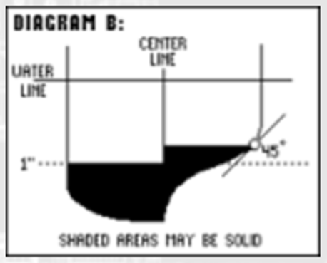
Change to:
6. Impenetrable material may be used as hull skin on a ship's bottom, but it shall end at least 1" below the center of the marked waterline, or more than 45 degrees down the turn of the bilge (see Diagram B).

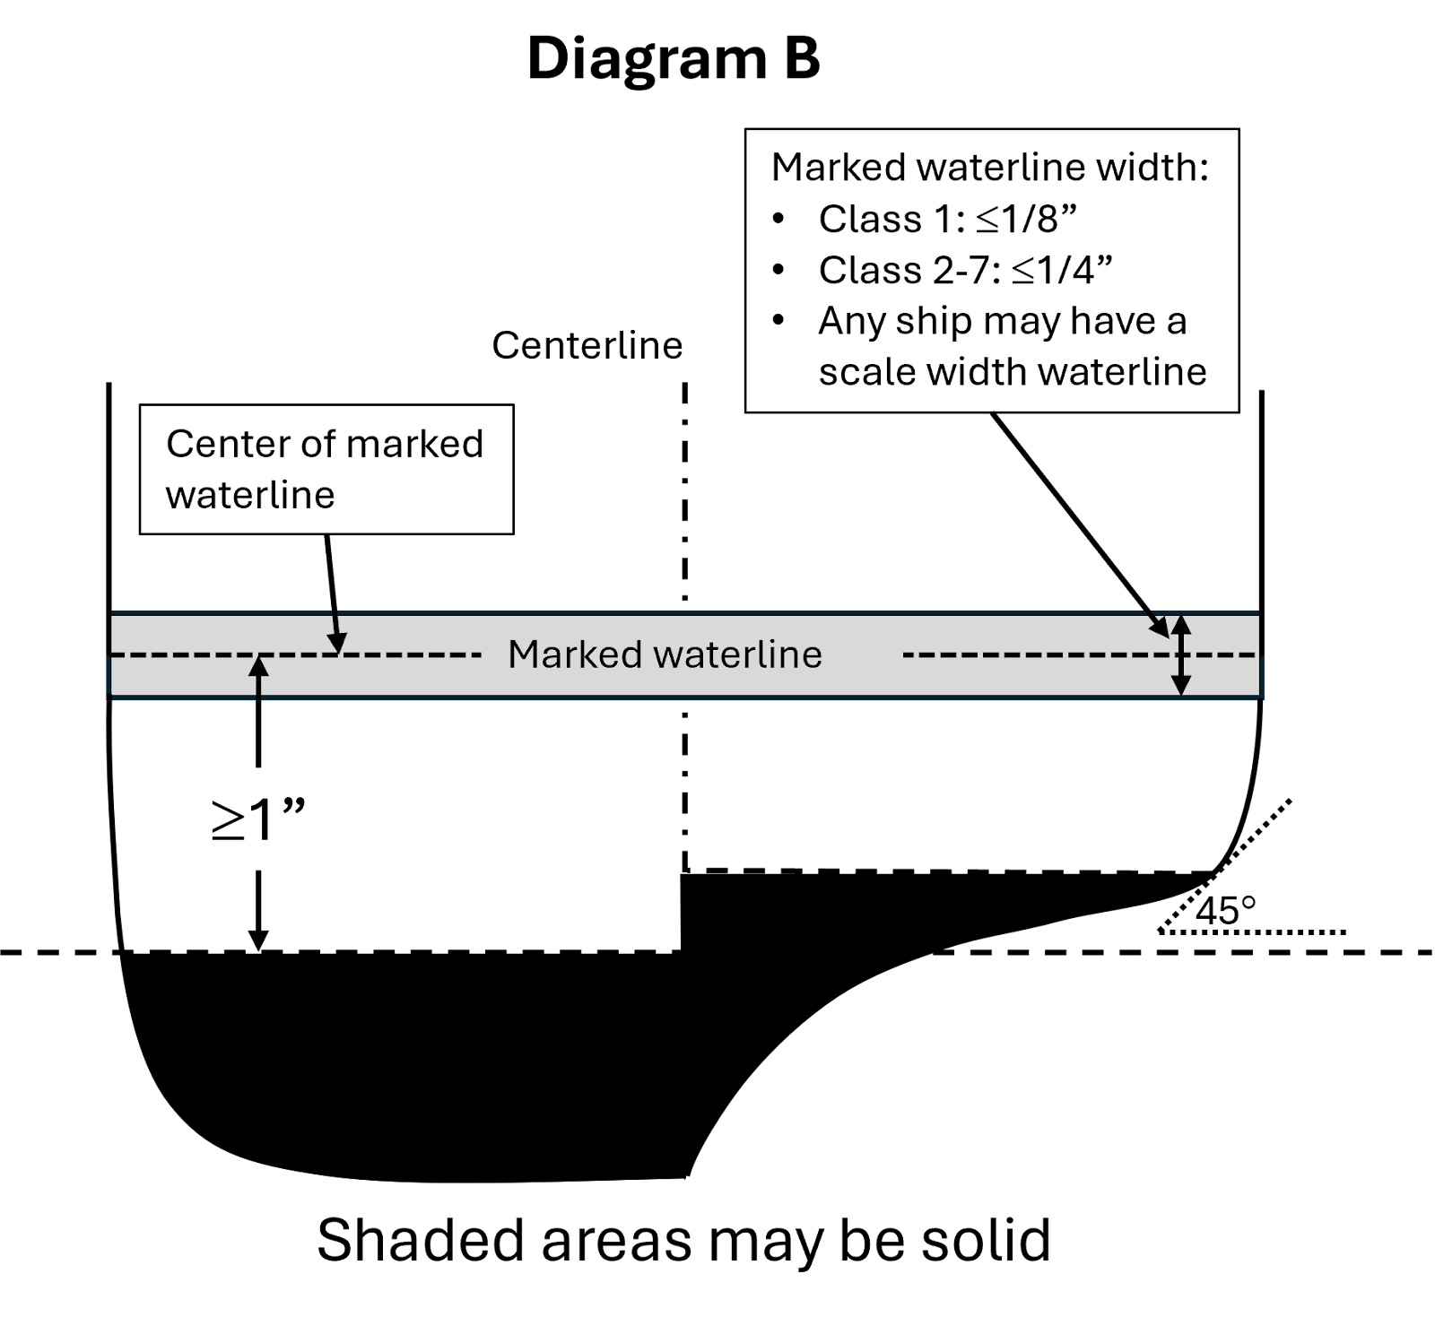

Existing
19. All ships shall have a minimum of ½ inch of freeboard (defined as the distance from the surface of the water to the top of the weather deck) while the ship is floating at rest without battle damage at all points along the hull. Hull depth shall be adjusted as required.

Change to:
19. All ships shall have a minimum of ½ inch of freeboard (defined as the distance from the surface of the water to the top of the weather deck) while the ship is floating at rest without battle damage at all points along the hull. Hull depth may be increased as required (see Diagram C).
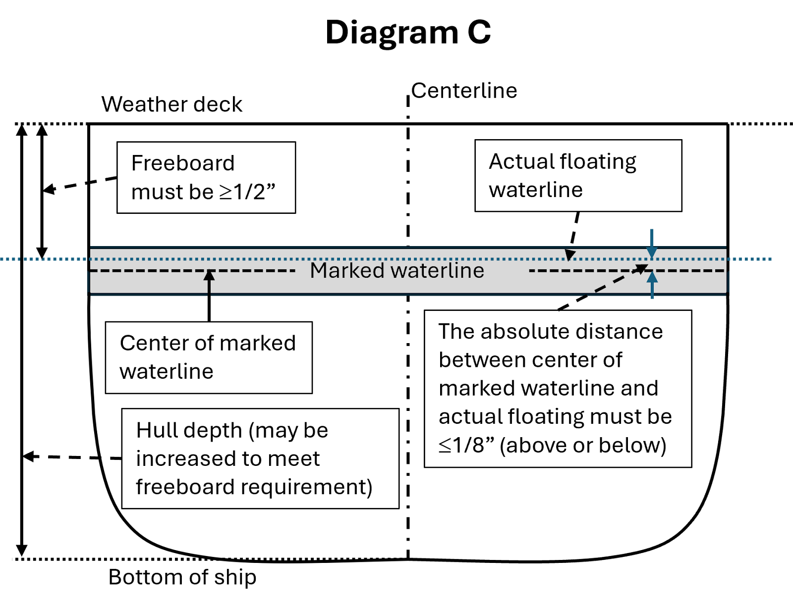

C. SCALE AND PROPORTIONS

Existing:
4. Each ship shall have a marked waterline. The center of the marked waterline shall be within 1/8" of the actual floating waterline of the ship. Ships in Classes 7 through 2 may have up to a 1/4" wide taped or painted waterline, and ships in Classes 1 and 1/2 may have up to a 1/8" wide taped or painted waterline. Any class of ship may have a scale width waterline.

Change to:
4. Each ship shall have a marked waterline. The center of the marked waterline shall be within 1/8" of the actual floating waterline of the ship. Ships in Classes 7 through 2 may have up to a 1/4" wide taped or painted waterline, and ships in Classes 1 and 1/2 may have up to a 1/8" wide taped or painted waterline. Any class of ship may have a scale width waterline. (see Diagrams B and C).

Reasoning: to clearly state that there must be 1” below the center of the marked waterline, to prevent a situation where boats have only 0.75” below the marked waterline (if the 1” is required to be measured from the floating waterline. The reasons for having the reference be the marked waterline rather than the floating waterline are:
- Scoring is based on the marked waterline, not the floating
- Ease of verification. Checking window depth from the marked waterline is a simple measurement on the bench. Checking versus the floating waterline involves patching the boat, floating the boat, noting where the floating waterline is relative to the marked waterline along the full length, then removing the boat from water and measuring from the floating waterline to the window depth.
- The floating waterline varies with minor changes in weight distribution side-to-side or fore-to-aft. The marked waterline does not change position, and the window depth is also fixed. It is not logical to have a fixed requirement (1”) be relative to something that varies easily (dist from floating waterline to bottom of windows).

2nd change: to remove the possible interpretation that hull depth could be reduced as long as ½” of freeboard could be maintained. Reducing hull depth offers a significant advantage as it gives increased maneuverability with reduced freeboard (assuming a lower running weight).
3rd change: Add reference to diagrams B and C

